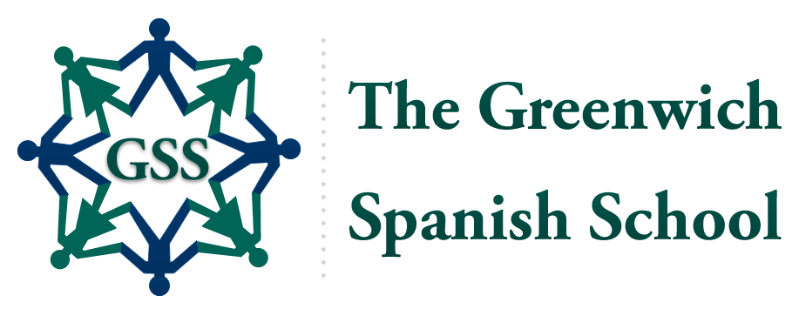
2020
Summer
Programs

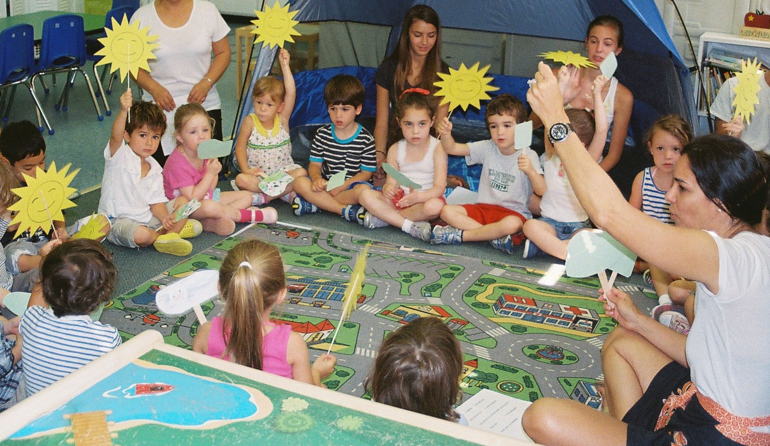

✰ Fun, creative programs and activities to
introduce children to another language
✰ Arts, crafts, music, dance, outdoor and
cultural activities – all in Spanish!

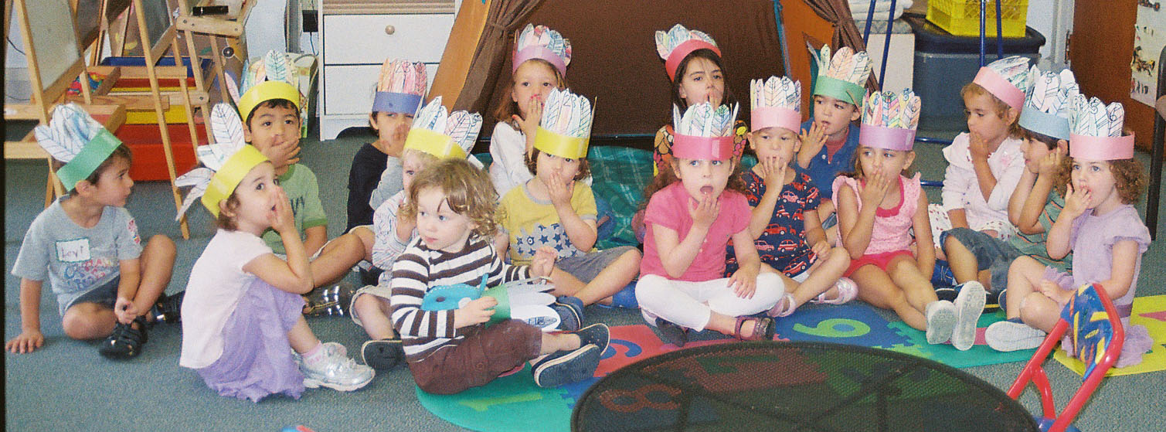
- For children 3-5 and 6-10 years old
- No prior knowledge of Spanish needed
- Visit www.GreenwichSpanish.org for details

The Greenwich Spanish School
is located in the O’Connor Center – 6 Riverside Avenue – Room 108-9
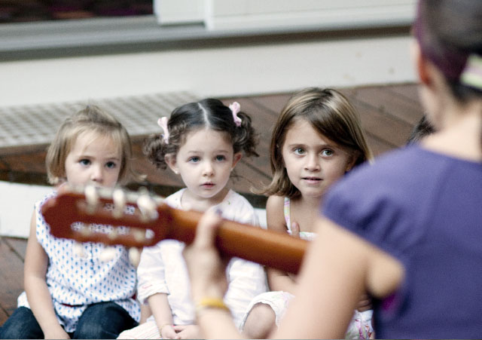
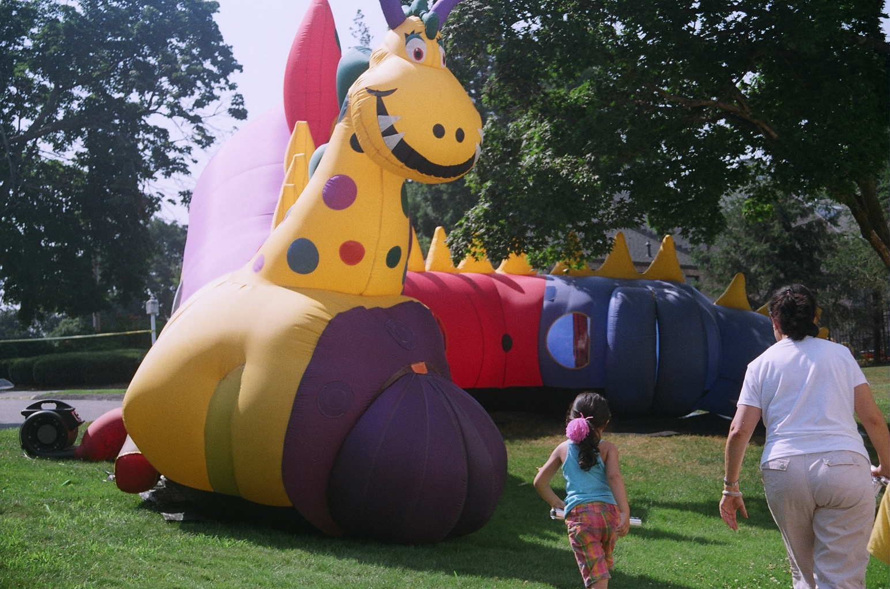
(next to Saint Catherine of Siena Church)
Contact:
Rosario J. Brooks, Director
(203) 698-1500
Rosario@GreenwichSpanish.org
Licensed by the CT Dept of Health

Summer Program Schedules
First Session June 1 – 12 3-10 years Half day: Mon - Fri 9:00 am to 12:00 pm
3-10 years Full day: Mon - Fri 9:00 am to 3:00 pm
Second Session June 15 – 26 3-10 years Half day: Mon - Fri 9:00 am to 12:00 pm
3-10 years Full day: Mon - Fri 9:00 am to 3:00 pm
Third Session July 6 – 17 3-10 years Half day: Mon - Fri 9:00 am to 12:00 pm
3-10 years Full day: Mon - Fri 9:00 am to 3:00 pm
Fourth Session July 20 – 31 3-10 years Half day: Mon - Fri 9:00 am to 12:00 pm
3-10 years Full day: Mon - Fri 9:00 am to 3:00 pm
Fifth Session August 3 – 14 3-10 years Half day: Mon - Fri 9:00 am to 12:00 pm
3-10 years Full day: Mon - Fri 9:00 am to 3:00 pm

(Children are also welcome for single weeks)

Program Fees Half day: $250 per child per week - $495 per child per 2-week session
Full day: $495 per child per week - $990 per child per 2-week session
★ All teachers and assistant teachers are native or have native fluency in Spanish.
★ All volunteers are fluent in Spanish.



